1. correclation test

(1) Chart5: Line Chart of Crude oil price and Southwest airline stock price

|  |  |  |  |
| --- | --- | --- | --- |
| **Chart7:Pearson Correlations Test** | | | |
|  | | Stock Price | Oil Price |
| Stock Price | Pearson Correlation | 1 | -.782** |
| Sig. (2-tailed) |  | .000 |
| N | 1531 | 1530 |
| Oil Price | Pearson Correlation | -.782** | 1 |
| Sig. (2-tailed) | .000 |  |
| N | 1531 | 1531 |

3. **regression line Model**

(1) notation

|  |  |  |
| --- | --- | --- |
| Notation | Value | unit |
| X | Crude oil price | Dollar |
| S | Southwest Share Price | Dollar |

(2) model

|  |  |  |  |  |  |
| --- | --- | --- | --- | --- | --- |
| **Coefficients** | | | | | |
|  | Unstandardized Coefficients | | Standardized Coefficients | t | Sig. |
| B | Std. Error | Beta |
| ln(VALUE) | -31.239 | .610 | -.795 | -51.192 | .000 |
| (Constant) | 157.237 | 2.665 |  | 58.992 | .000 |

$$\ln\left(Y\right)=157.237-31.239\ln\left(X\right)$$

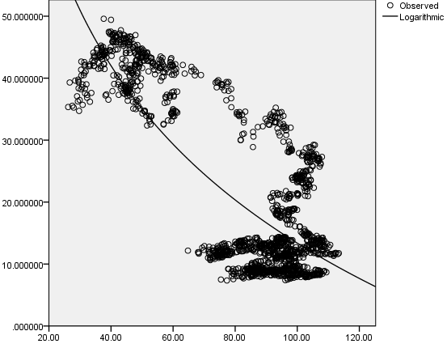

|  |  |  |  |
| --- | --- | --- | --- |
| **Model Summary** | | | |
| R | R Square | Adjusted R Square | Std. Error of the Estimate |
| .795 | .632 | .631 | 8.038 |
| The independent variable is VALUE. | | | |